**Linux Terminal Commands**

**1) mkdir**

mkdir (or make directory) is used to create a new directory.

**Syntax:** mkdir <directory name>

**2) cd**

cd (or change directory) is used to navigate to different directories.

**Syntax:** cd <directory path>

To Move out of a directory use the following commands.

* cd ../-Use to move out of sub directory.
* cd \-Use to move out of multiple sub directories.

**3) touch**

It is used to create an empty file.

**Syntax:** touch <filename + extension>

**4) cat**

It can be used to edit, view or merge files.

**Syntax:**

(i) cat > <filename> - allows editing the file, ctrl+D is used to save and exit

(ii) cat <filename> - displays the contents of the file

(iii) cat <file1> <file2> > <file3> - merges the content of file1 & file2 in file3

**5) ls**

It is used to display the contents of a directory.

**Syntax:**

ls - will display all types of files and directories

**(6) ls \***

Will only display files with specified extension

**Syntax:** ls *.<extension name>

**7) pwd**

It displays the complete path of the current working directory.

**Syntax:** pwd

**8) cp**

It is used to copy a file from one directory to another.

**Syntax:** cp <file path> <location where the file must be copied to>

**9) mv**

It is used to move a file from one directory to another. The file is removed from the original location.

**Syntax:** mv <file path> <location where the file must be moved to>

**10) head**

Displays the first 10 lines of content of a file.

**Syntax:** head <filename>

**11) tail**

Displays the last 10 lines of content of a file.

**Syntax:** tail <filename>

**12) tac**

Displays the content of a file in reverse order.

**Syntax:** tac <filename>

**13) more**

Displays the content of large files.

**Syntax:** More <filename>

**14) vi**

Used to edit a file. After entering the command, and hitting enter, one must input ‘i’ to open insert mode. After making the changes, :wq must be entered.

**Syntax:** vi <filename>

The following are basic commands used in a Vim Text Editor.

* :q- To exit Vim.
* :! - To override previous commands.
* :wq - To write and quit.
* :w- to save

**15) id**

It is used to display id of user/group.

**Syntax:** id

**16) clear**

It is used to clear the screen.

**Syntax:** clear

**17)** **vi**

It is a text editor used to write programs of text.

**18) grep**

Filter to search the given pattern in the file content.

**Syntax:** grep <word> <filename.txt>

**19) diff**

It is used to compare the content between two files.

**Syntax:** diff <filename1.txt> <filename2.txt>

**20) ping**

It is used to check the connectivity status of the user.

**Syntax:** ping <searchengine>

**21) history**

It is used to review all the commands that you have entered.

**Syntax:** history

**22) hostname**

It is used to display hostname of the user.

**Syntax:** hostname

**23) hostname-i**

It is used to display hostname ip .

**Syntax:** hostname -i

**24) chmod**

It is used to change the user/group permissions to access a file.

**Syntax:**

* For read only : chmod u=r
* For write only: chmod u=w

**25) nl**

It is used to display the line numbers.

**Syntax:** nl <filename.txt>

**26) wc**

It is used to display the no. of lines, words and characters available in the file content.

**Syntax:** wc <filename.txt>

**27) uniq**

It is used to remove duplicate file contents but it can remove only continuous duplicates.

**Syntax:** uniq

**28) ps**

It prints the report of the current processes.

**Syntax:** ps

**29) rmdir**

It removes the specified directory(directory should be empty).

**Syntax:** rmdir <directory name>

**30) rm**

It removes the file .

**Syntax:** rm <filename>

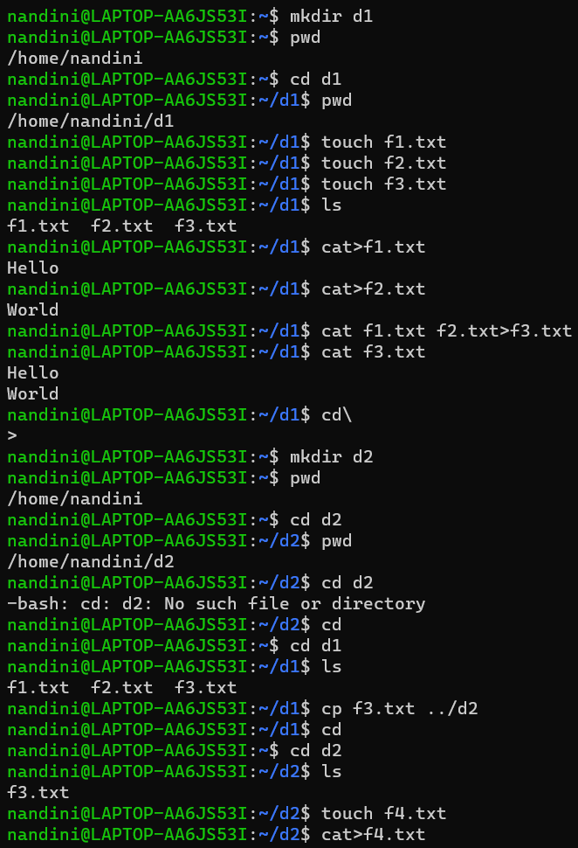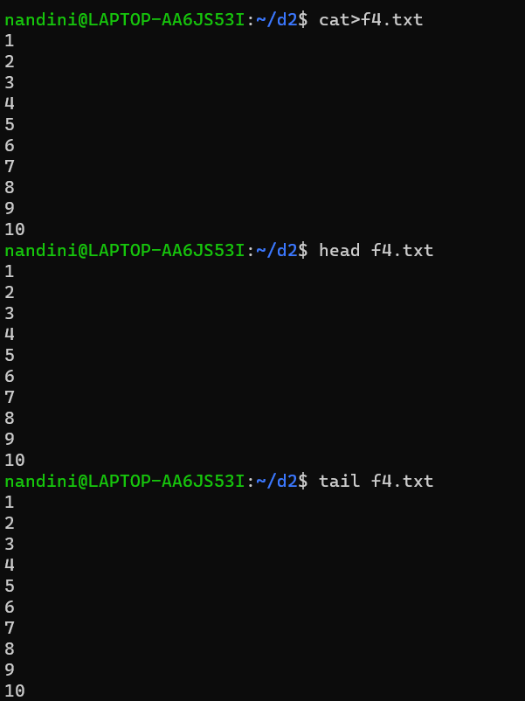

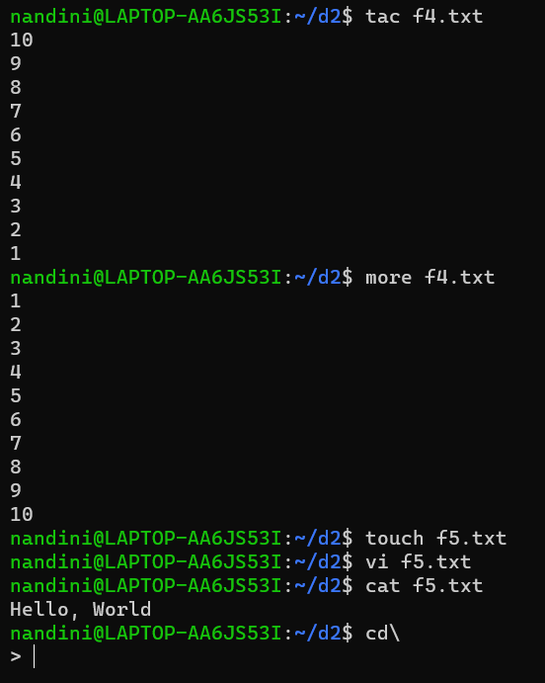

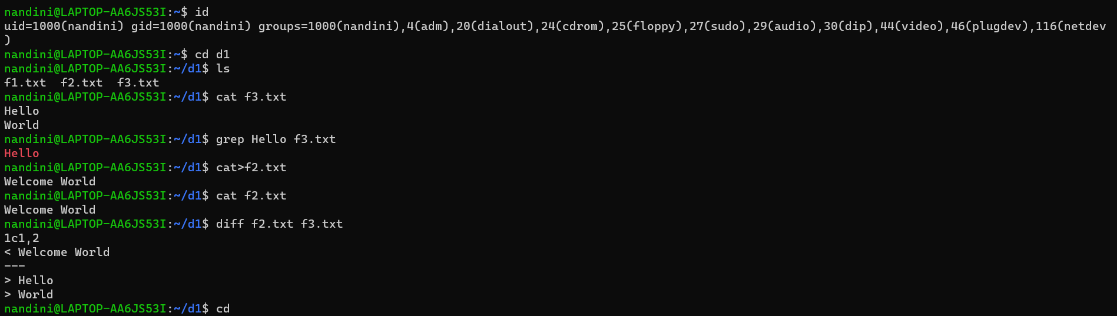

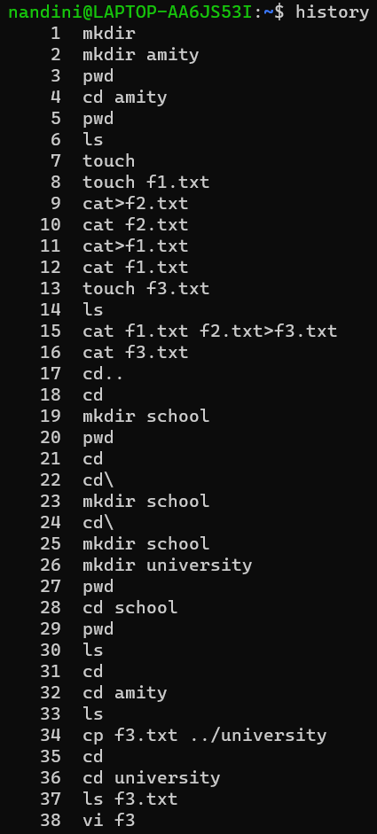 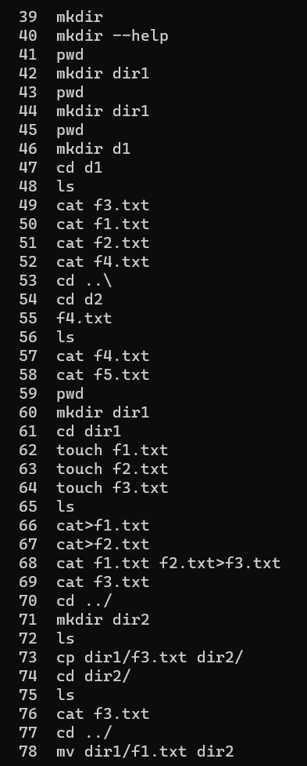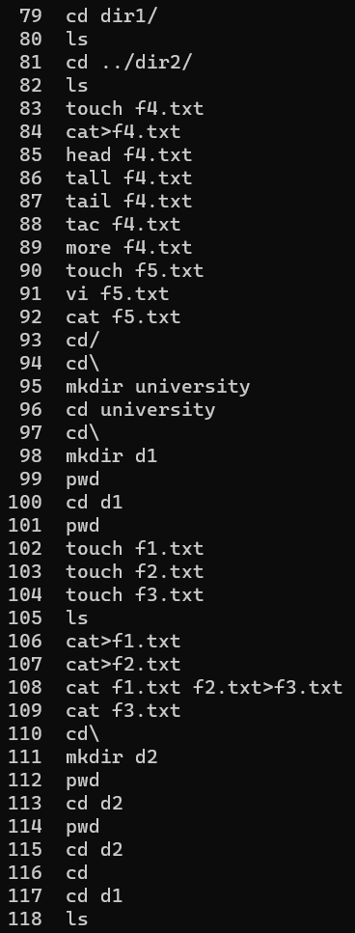

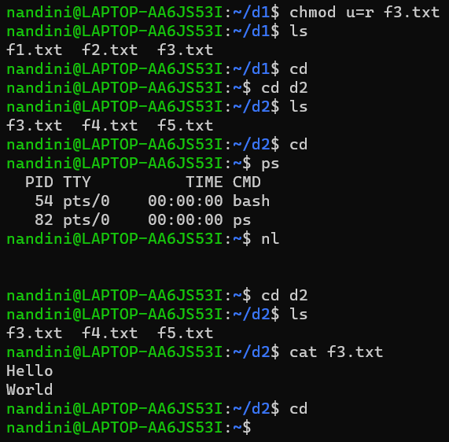

**Linux Shell Commands**

1. **$cat /etc/shells**

Used to find the available shells in your system.

1. **$ chmod +x file_name.txt**

Used to execute the permission for a script.

1. **. ./file_name.txt**

Used to execute a file.

1. **Echo**

Used to print the content.

* echo “My name is Nandini Sain”
* echo -e ”\033[0;31m Message” : - Used to change the colour of the text.
* name=”nandini sain”

age=”19”

echo “ my name is {$name} and my age is{$age}.

1. **which bash**

It tells the user to tell the path.

1. **env**

It will display all the system commands.

Some of them are: -

* echo $SHELL
* echo $HOME
* echo $OSTYPE
* echo $PATH
* echo $$: - tells the process id.
* echo $PPID: -tells the parent process id.
* echo $PWD

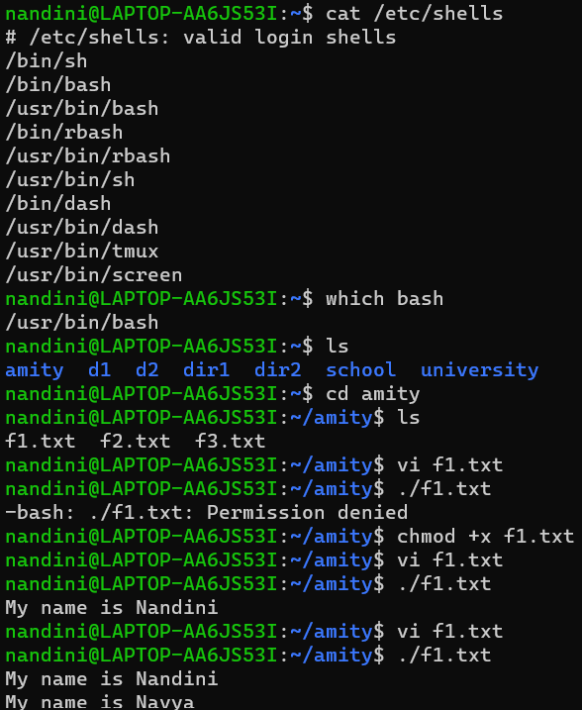

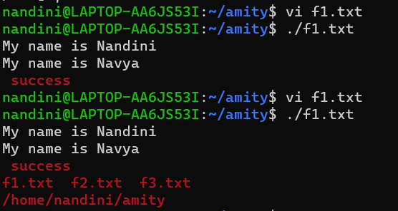

**Linux Shell Programs**

1. Write a shell script for addition of two numbers.

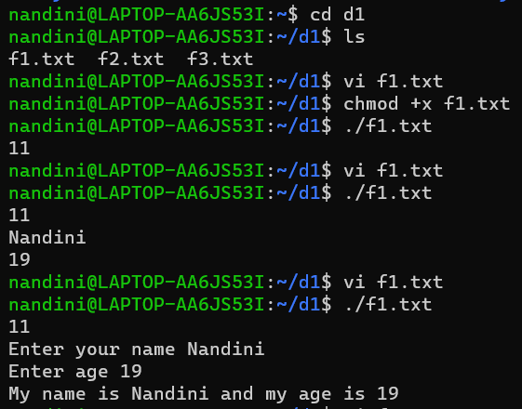

1. Write a shell script to print the name and the age.

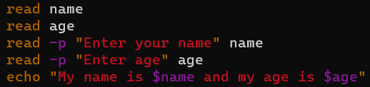

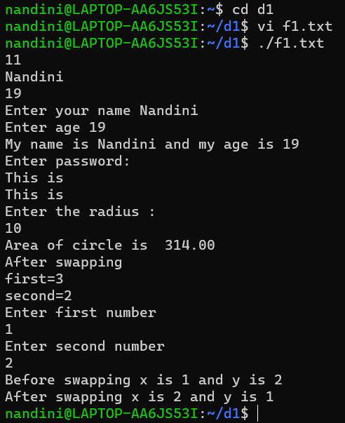

1. Write a shell script to enter the password and input two values.

1. Write a shell script for calculating the area of circle. Radius is to be entered by user.

1. Write a shell script for swapping two numbers:

(i) Using third variable

(ii) Using without third variable

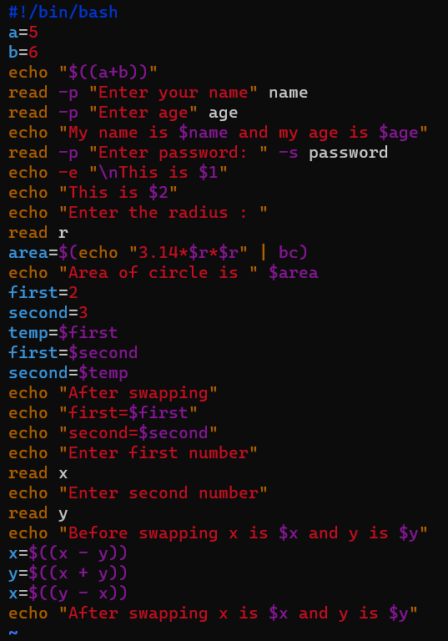

1. Write the following for commands.
2. Shell Script Name ($0),
3. No. of Arguments (i.e., $#),
4. And actual argument (i.e. $1, $2 etc.)
5. $ sum (11, 20)
6. $ math (4 – 7)
7. $ Ls *
8. $ cal

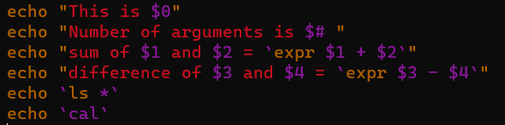

**Shell Script**

Some Basic Commands Used in GNU Linux Commands are-

1. Write a shell script to find the factorial of any number.

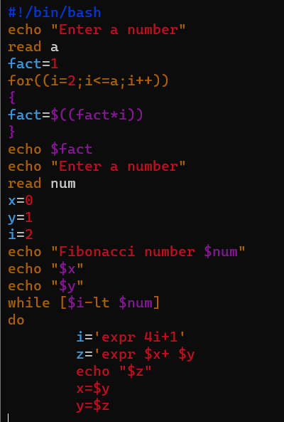

1. Write a shell script to print the Fibonacci series of ‘n’ elements and print the sum of the given series.

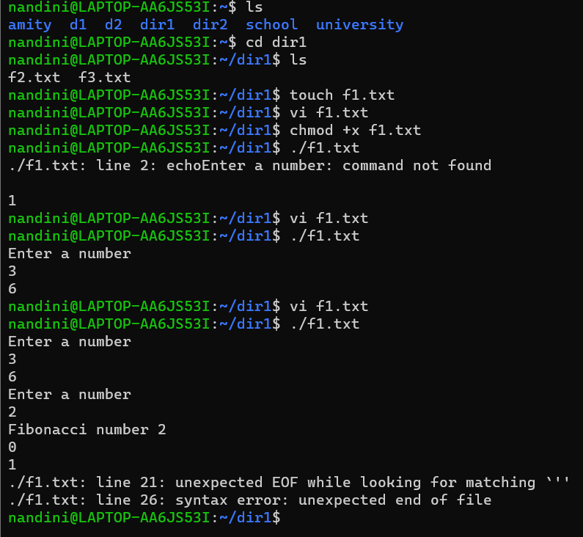

1. Write a shell script for simple calculator.

1. Write a shell script that accept a file name starting and ending line numbers as arguments and display all the lines between given line number.

1. Write a shell script that delete all lines containing a specified word.

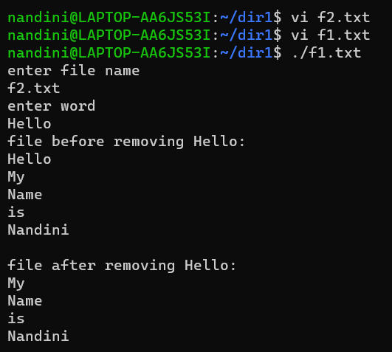

1. Write a shell script that displays a list of all the files in the current directory

**FCFS ALGORITHM**

//C Program to demonstrate the First Come First Serve CPU Scheduling Algorithm .

//CODE

#include <stdio.h>

void calculateTime(int process[], int n, int arrival[], int burst[])

{

int exit[n], turn_around[n], waiting_time[n];

float avg_waiting_time = 0, avg_turn_around_time = 0;

exit[0] = arrival[0] + burst[0];

for (int i = 1; i < n; i++)

exit[i] = exit[i - 1] + burst[i];

for (int i = 0; i < n; i++)

{

turn_around[i] = exit[i] - arrival[i];

waiting_time[i] = turn_around[i] - burst[i];

avg_waiting_time += waiting_time[i];

avg_turn_around_time += turn_around[i];

}

avg_waiting_time /= n;

avg_turn_around_time /= n;

printf("\nProcess\t Arrival Time\t Burst Time\t Exit Time\t Turn Around Time\t Waiting Time\n");

for (int i = 0; i < n; i++)

printf("%d\t\t %d\t\t %d\t\t %d\t\t %d\t\t %d\n", process[i], arrival[i], burst[i], exit[i],

turn_around[i], waiting_time[i]);

printf("\nAverage Waiting Time: %.2f\n", avg_waiting_time);

printf("Average Turn Around Time: %.2f\n", avg_turn_around_time);

}

int main()

{

int n;

printf("Enter the number of processes: ");

scanf("%d", &n);

int process[n], arrival[n], burst[n];

printf("Enter the arrival time and burst time for each process:\n");

for (int i = 0; i < n; i++)

{

process[i] = i + 1;

printf("\nEnter the arrival time: ");

scanf("%d", &arrival[i]);

printf("\nEnter the burst time: ");

scanf("%d",&burst[i]);

}

calculateTime(process, n, arrival, burst);

return 0;

}

**OUTPUT**

**SJF ALGORITHM**

//C Program to demonstrate the Shortest Job First (SJF) CPU Scheduling Algorithm .

//CODE

#include <stdio.h>

struct process{

int pid;

int at;

int bt;

int prior;

int tat;

int wt;

int comp;

};

typedef struct process process;

int main()

{

int n;

printf("Enter the number of processes: ");

scanf("%d",&n);

process p_array[n];

for(int i =0;i<n;i++)

{

printf("Enter process id: ");

scanf("%d",&p_array[i].pid);

printf("Enter process arrival time: ");

scanf("%d",&p_array[i].at);

printf("Enter process burst time: ");

scanf("%d",&p_array[i].bt);

p_array[i].tat =0;

p_array[i].wt =0;

p_array[i].prior =0;

p_array[i].comp =0;

}

int cpu_time=0;

int t_n = n;

while(t_n>0)

{

int j=-1;

for(int i=0;i<n;i++)

{

if(j==-1 && p_array[i].at<=cpu_time && p_array[i].comp==0)

{

j=i;

}

else if(p_array[i].at<=cpu_time && p_array[i].comp==0 && p_array[j].bt>p_array[i].bt)

{

j=i;

}

}

if(j!=-1)

{

cpu_time+=p_array[j].bt;

p_array[j].tat = cpu_time-p_array[j].at;

p_array[j].wt = p_array[j].tat - p_array[j].bt;

p_array[j].comp = 1;

t_n-=1;

}

else

{

cpu_time+=1;

}

}

float t_wt = 0;

for(int i =0;i<n;i++)

{

t_wt += p_array[i].wt;

printf("%d %d %d %d %d",p_array[i].pid,p_array[i].at,p_array[i].bt,p_array[i].tat,p_array[i].wt);

printf("\n");

}

printf("%f",t_wt/n);

    return 0;

}

**OUTPUT**

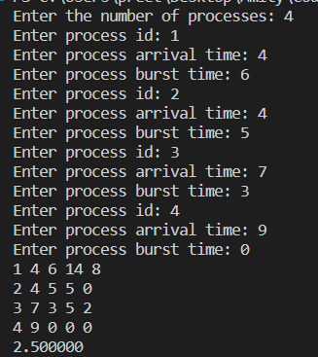

**SRTF ALGORITHM**

//C Program to demonstrate the Shortest Remaining Time First (SRTF)

CPU Scheduling Algorithm.

//CODE

#include <stdio.h>

struct process{

int pid;

int at;

int bt;

int t_bt;

int prior;

int tat;

int wt;

int comp;

};

typedef struct process process;

int main()

{

int n;

printf("Enter the number of processes: ");

scanf("%d",&n);

process p_array[n];

for(int i =0;i<n;i++)

{

printf("Enter process id: ");

scanf("%d",&p_array[i].pid);

printf("Enter process arrival time: ");

scanf("%d",&p_array[i].at);

printf("Enter process burst time: ");

scanf("%d",&p_array[i].bt);

p_array[i].t_bt=p_array[i].bt;

p_array[i].tat =0;

p_array[i].wt =0;

p_array[i].prior =0;

p_array[i].comp =0;

}

int cpu_time=0;

int t_n = n;

while(t_n>0)

{

int j=-1;

for(int i=0;i<n;i++)

{

if(j==-1 && p_array[i].at<=cpu_time && p_array[i].comp==0)

{

j=i;

}

else if(p_array[i].at<=cpu_time && p_array[i].comp==0 && p_array[j].bt>p_array[i].bt)

{

j=i;

}

}

if(j!=-1)

{

cpu_time+=1;

p_array[j].bt-=1;

if(p_array[j].bt==0)

{

p_array[j].tat = cpu_time-p_array[j].at;

p_array[j].wt = p_array[j].tat - p_array[j].t_bt;

p_array[j].comp = 1;

t_n-=1;

}

}

else

{

cpu_time+=1;

}

}

float t_wt = 0;

for(int i =0;i<n;i++)

{

t_wt += p_array[i].wt;

printf("%d %d %d %d %d",p_array[i].pid,p_array[i].at,p_array[i].t_bt,p_array[i].tat,p_array[i].wt);

printf("\n");

}

printf("%f",t_wt/n);

return 0;

}

**OUTPUT**

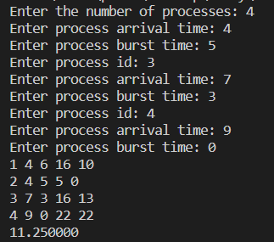

**PRIORITY SCHEDULING ALGORITHM**

//1. C Program to demonstrate the Priority Scheduling Algorithm (Non-Preemptive)

//CODE

#include<stdio.h>

#define MIN -9999;

struct proc

{

int no,at,bt,ct,wt,tat,pri,status;

};

struct proc read(int i)

{

struct proc p;

printf("\nProcess No: %d\n",i);

p.no=i;

printf("Enter Arrival Time: ");

scanf("%d",&p.at);

printf("Enter Burst Time: ");

scanf("%d",&p.bt);

printf("Enter Priority: ");

scanf("%d",&p.pri);

p.status=0;

return p;

}

int main()

{

int n,l,ct=0,remaining;

struct proc p[10],temp;

float avgtat=0,avgwt=0;

printf("<--Highest Priority First Scheduling Algorithm (Non-Preemptive)-->\n");

printf("Enter Number of Processes: ");

scanf("%d",&n);

for(int i=0;i<n;i++)

p[i]=read(i+1);

for(int i=0;i<n-1;i++)

for(int j=0;j<n-i-1;j++)

if(p[j].at>p[j+1].at)

{

temp=p[j];

p[j]=p[j+1];

p[j+1]=temp;

}

p[9].pri=MIN;

remaining=n;

printf("\nProcessNo\tAT\tBT\tPri\tCT\tTAT\tWT\tRT\n");

for(ct=p[0].at;remaining!=0;)

{

l=9;

for(int i=0;i<n;i++)

if(p[i].at<=ct && p[i].status!=1 && p[i].pri>p[l].pri)

l=i;

p[l].ct=ct=ct+p[l].bt;

p[l].tat=p[l].ct-p[l].at;

avgtat+=p[l].tat;

p[l].wt=p[l].tat-p[l].bt;

avgwt+=p[l].wt;

p[l].status=1;

remaining--;

printf("P%d\t\t%d\t%d\t%d\t%d\t%d\t%d\t%d\n",p[l].no,p[l].at,p[l].bt,p[l].pri,p[l].ct,p[l].tat,p[l].wt,

p

[l].wt);

}

avgtat/=n;

avgwt/=n;

printf("\nAverage TurnAroundTime=%f\nAverage WaitingTime=%f",avgtat,avgwt);

}

**OUTPUT**

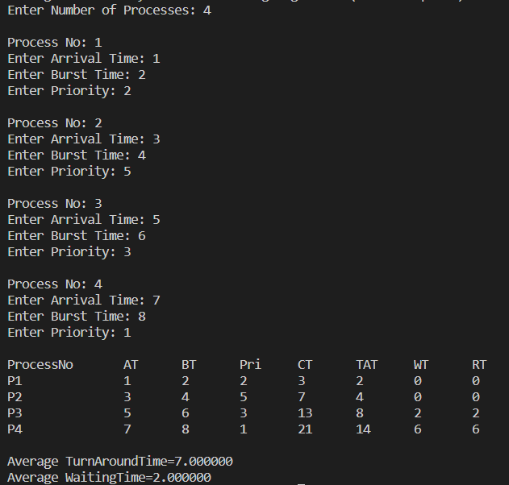

//2. C Program to demonstrate the Priority Scheduling Algorithm (Preemptive)

//CODE

#include<stdio.h>

#define MIN -9999;

struct proc

{

int no,at,bt,rt,ct,wt,tat,pri,temp;

};

struct proc read(int i)

{

struct proc p;

printf("\nProcess No: %d\n",i);

p.no=i;

printf("Enter Arrival Time: ");

scanf("%d",&p.at);

printf("Enter Burst Time: ");

scanf("%d",&p.bt);

p.rt=p.bt;

printf("Enter Priority: ");

scanf("%d",&p.pri);

p.temp=p.pri;

return p;

}

int main()

{

int i,n,c,remaining,max_val,max_index;

struct proc p[10],temp;

float avgtat=0,avgwt=0;

printf("<--Highest Priority First Scheduling Algorithm (Preemptive)-->\n");

printf("Enter Number of Processes: ");

scanf("%d",&n);

for(int i=0;i<n;i++)

p[i]=read(i+1);

remaining=n;

for(int i=0;i<n-1;i++)

for(int j=0;j<n-i-1;j++)

if(p[j].at>p[j+1].at)

{

temp=p[j];

p[j]=p[j+1];

p[j+1]=temp;

}

max_val=p[0].temp,max_index=0;

for(int j=0;j<n&&p[j].at<=p[0].at;j++)

if(p[j].temp>max_val)

max_val=p[j].temp,max_index=j;

i=max_index;

c=p[i].ct=p[i].at+1;

p[i].rt--;

if(p[i].rt==0)

{

p[i].temp=MIN;

remaining--;

}

while(remaining>0)

{

max_val=p[0].temp,max_index=0;

for(int j=0;j<n&&p[j].at<=c;j++)

if(p[j].temp>max_val)

max_val=p[j].temp,max_index=j;

i=max_index;

p[i].ct=c=c+1;

p[i].rt--;

if(p[i].rt==0)

{

p[i].temp=MIN;

remaining--;

}

}

printf("\nProcessNo\tAT\tBT\tPri\tCT\tTAT\tWT\n");

for(int i=0;i<n;i++)

{

p[i].tat=p[i].ct-p[i].at;

avgtat+=p[i].tat;

p[i].wt=p[i].tat-p[i].bt;

avgwt+=p[i].wt;

printf("P%d\t\t%d\t%d\t%d\t%d\t%d\t%d\n",p[i].no,p[i].at,p[i].bt,p[i].pri,p[i].ct,p[i].tat,p[i].wt);

}

avgtat/=n,avgwt/=n;

printf("\nAverage TurnAroundTime=%f\nAverage WaitingTime=%f",avgtat,avgwt);

}

**OUTPUT**

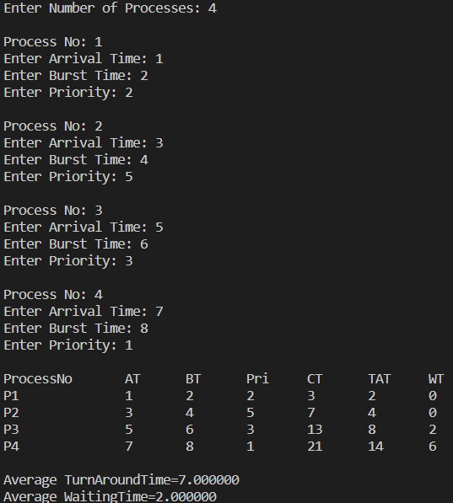

**ROUND ROBIN SCHEDULING ALGORITHM**

//C++ Program to demonstrate the Round Robin Scheduling Algorithm

//CODE

#include <iostream>

#include <cstdlib>

#include <queue>

#include <cstdio>

using namespace std;

typedef struct process

{

    int id, at, bt, st, ft, pr;

    float wt, tat;

}

process;

process p[10], p1[10], temp;

queue<int> q1;

int accept(int ch);

void turnwait(int n);

void display(int n);

void ganttrr(int n);

int main()

{

    int i, n, ts, ch, j, x;

    p[0].tat = 0;

    p[0].wt = 0;

    n = accept(ch);

    ganttrr(n);

    turnwait(n);

    display(n);

    return 0;

}

int accept(int ch)

{

    int i, n;

    printf("Enter the Total Number of Process to Round Robin: ");

    scanf("%d", &n);

    if (n == 0)

    {

        printf("Invalid");

        exit(1);

    }

    cout << endl;

    for (i = 1; i <= n; i++)

    {

        printf("Enter an Arrival Time of the Process to Round Robin P%d: ", i);

        scanf("%d", &p[i].at);

        p[i].id = i;

    }

    cout << endl;

    for (i = 1; i <= n; i++)

    {

        printf("Enter a Burst Time of the Process to Round Robin P%d: ", i);

        scanf("%d", &p[i].bt);

    }

    for (i = 1; i <= n; i++)

    {

        p1[i] = p[i];

    }

    return n;

}

void ganttrr(int n)

{

    int i, ts, m, nextval, nextarr;

    nextval = p1[1].at;

    i = 1;

    cout << "\nEnter the Time Slice or Quantum: ";

    cin >> ts;

    for (i = 1; i <= n && p1[i].at <= nextval; i++)

    {

        q1.push(p1[i].id);

    }

    while (!q1.empty())

    {

        m = q1.front();

        q1.pop();

        if (p1[m].bt >= ts)

        {

            nextval = nextval + ts;

        }

        else

        {

            nextval = nextval + p1[m].bt;

        }

        if (p1[m].bt >= ts)

        {

            p1[m].bt = p1[m].bt - ts;

        }

        else

        {

            p1[m].bt = 0;

        }

        while (i <= n && p1[i].at <= nextval)

        {

            q1.push(p1[i].id);

            i++;

        }

        if (p1[m].bt > 0)

        {

            q1.push(m);

        }

        if (p1[m].bt <= 0)

        {

            p[m].ft = nextval;

        }

    }

}

void turnwait(int n)

{

    int i;

    for (i = 1; i <= n; i++)

    {

        p[i].tat = p[i].ft - p[i].at;

        p[i].wt = p[i].tat - p[i].bt;

        p[0].tat = p[0].tat + p[i].tat;

        p[0].wt = p[0].wt + p[i].wt;

    }

    p[0].tat = p[0].tat / n;

    p[0].wt = p[0].wt / n;

}

void display(int n)

{

    int i;

    cout<<"\n\n\n";

    printf("\nPID\tAT\tBT\tFT\tTAT\t\tWT");

    for (i = 1; i <= n; i++)

    {

        printf("\nP%d\t%d\t%d\t%d\t%.3f\t%.3f", p[i].id, p[i].at, p[i].bt, p[i].ft, p[i].tat, p[i].wt);

    }

    printf("\nAverage Turn Around Time: %.3f", p[0].tat);

    printf("\nAverage Waiting Time: %.3f", p[0].wt);

}

OUTPUT

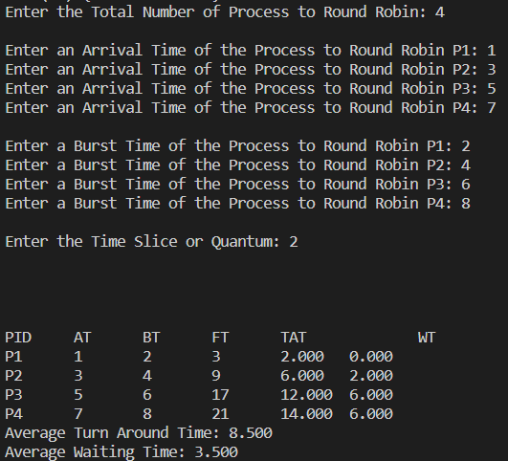

**BANKER’S ALGORITHM**

//C Program to demonstrate the Round Robin Scheduling Algorithm

//CODE

#include <stdio.h>

#include <conio.h>

int main()

{

int Max[10][10], need[10][10], alloc[10][10], avail[10], completed[10], safeSequence[10];

int p, r, i, j, process, count;

count = 0;

printf("Enter the no of processes : ");

scanf("%d", &p);

for(i = 0; i< p; i++)

completed[i] = 0;

printf("\n\nEnter the no of resources : ");

scanf("%d", &r);

printf("\n\nEnter the Max Matrix for each process : ");

for(i = 0; i < p; i++)

{

printf("\nFor process %d : ", i + 1);

for(j = 0; j < r; j++)

scanf("%d", &Max[i][j]);

}

printf("\n\nEnter the allocation for each process : ");

for(i = 0; i < p; i++)

{

printf("\nFor process %d : ",i + 1);

for(j = 0; j < r; j++)

scanf("%d", &alloc[i][j]);

}

printf("\n\nEnter the Available Resources : ");

for(i = 0; i < r; i++)

scanf("%d", &avail[i]);

for(i = 0; i < p; i++)

for(j = 0; j < r; j++)

need[i][j] = Max[i][j] - alloc[i][j];

do

{

printf("\n Max matrix:\tAllocation matrix:\n");

for(i = 0; i < p; i++)

{

for( j = 0; j < r; j++)

printf("%d ", Max[i][j]);

printf("\t\t");

for( j = 0; j < r; j++)

printf("%d ", alloc[i][j]);

printf("\n");

}

process = -1;

for(i = 0; i < p; i++)

{

if(completed[i] == 0)//if not completed

{

process = i ;

for(j = 0; j < r; j++)

{

if(avail[j] < need[i][j])

{

process = -1;

break;

}

}

}

if(process != -1)

break;

}

if(process != -1)

{

printf("\nProcess %d runs to completion!", process + 1);

safeSequence[count] = process + 1;

count++;

for(j = 0; j < r; j++)

{

avail[j] += alloc[process][j];

alloc[process][j] = 0;

Max[process][j] = 0;

completed[process] = 1;

}

}

}while(count != p && process != -1);

if(count == p)

{

printf("\nThe system is in a safe state!!\n");

printf("Safe Sequence : < ");

for( i = 0; i < p; i++)

printf("%d ", safeSequence[i]);

printf(">\n");

}

else

printf("\nThe system is in an unsafe state!!");

getch();

}

OUTPUT

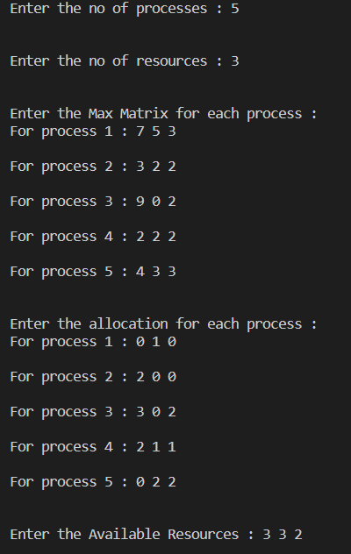



**FIFO PAGE REPLACEMENT ALGORITHM**

#include<stdio.h>

int main()

{

int i,j,n,a[50],frame[10],no,k,avail,count=0;

            printf("\n ENTER THE NUMBER OF PAGES:\n");

scanf("%d",&n);

            printf("\n ENTER THE PAGE NUMBER :\n");

            for(i=1;i<=n;i++)

            scanf("%d",&a[i]);

            printf("\n ENTER THE NUMBER OF FRAMES :");

            scanf("%d",&no);

for(i=0;i<no;i++)

            frame[i]= -1;

                        j=0;

                        printf("\tref string\t page frames\n");

for(i=1;i<=n;i++)

                        {

                                    printf("%d\t\t",a[i]);

                                    avail=0;

                                    for(k=0;k<no;k++)

if(frame[k]==a[i])

                                                avail=1;

                                    if (avail==0)

                                    {

                                                frame[j]=a[i];

                                                j=(j+1)%no;

                                                count++;

                                                for(k=0;k<no;k++)

                                                printf("%d\t",frame[k]);

}

                                    printf("\n");

}

                        printf("Page Fault Is %d",count);

                        return 0;

}

OUTPUT

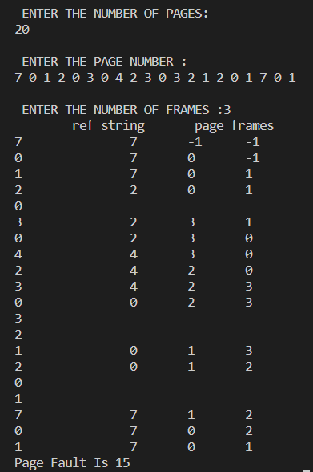

**OPTIMAL PAGE REPLACEMENT ALGORITHM**

#include <stdio.h>

#include <stdlib.h>

int search(int A[],int np,int p)

{

    int bool=0;

    for(int i = 0;i<np;i++)

    {

        if(p==A[i])

        {

            bool = 1;

            break;

        }

    }

    return(bool);

}

int * replace(int A[],int np,int p1,int p2)

{

    for(int i=0;i<np;i++)

    {

        if(A[i]==p1)

        {

            A[i]=p2;

            break;

        }

    }

    return(A);

}

void traverse_array(int A[], int n)

{

    for (int i = 0; i < n; i++)

    {

        if(A[i]==-1)

        {

            printf("_ ");

        }

        else

        {

            printf("%d ", A[i]);

        }

    }

    printf("\n");

}

int to_replace(int A[],int i,int np,int f[],int nf)

{

    int to_replace = -1;

    int last_use = -1;

    for(int j=0;j<nf;j++)

    {

        if(f[j]==-1)

        {

            to_replace = -1;

            break;

        }

        else

        {

            for(int k =i;k<np;k++)

            {

                if(A[k]==f[j])

                {

                    if(last_use==-1)

                    {

                        to_replace=f[j];

                        last_use=k;

                    }

                    else if(last_use<k)

                    {

                        to_replace=f[j];

                        last_use=k;

                    }

                    break;

                }

                else if(k==np-1)

                {

                    to_replace=f[j];

                    last_use=k;

                }

            }

        }

    }

    return(to_replace);

}

int main()

{

    int np;

    printf("Enter the number of pages: ");

    scanf("%d",&np);

    int nf;

    printf("Enter the number of frames: ");

    scanf("%d",&nf);

    int* frame = (int *)malloc(sizeof(int)*nf);

    int* pages = (int *)malloc(sizeof(int)*np);

    for(int i = 0;i<nf;i++)

    {

        frame[i]=-1;

    }

    for(int i =0;i<np;i++)

    {

        printf("Enter page %d: ",i);

        scanf("%d",&pages[i]);

    }

    printf("\n");

    int hit = 0;

    int fault = 0;

    for(int i = 0;i<np;i++)

    {

        traverse_array(frame,nf);

        printf("%d ",pages[i]);

        if(search(frame,nf,pages[i])==1)

        {

            printf(" Hit\n");

            hit+=1;

        }

        else

        {

            printf("Fault %d\n",to_replace(pages,i,np,frame,nf));

            int replace_page = to_replace(pages,i,np,frame,nf);

            fault+=1;

            frame = replace(frame,nf,replace_page,pages[i]);

        }

        printf("\n");

    }

    printf("Total Hit:%d\nTotal Fault:%d",hit,fault);

    return 0;

}

OUTPUT

**LEAST RECENTLY USED PAGE REPLACEMENT ALGORITHM**

#include<stdio.h>

main()

{

int q[20],p[50],c=0,c1,d,f,i,j,k=0,n,r,t,b[20],c2[20];

printf("Enter no of pages:");

scanf("%d",&n);

printf("Enter the reference string:");

for(i=0;i<n;i++)

            scanf("%d",&p[i]);

printf("Enter no of frames:");

scanf("%d",&f);

q[k]=p[k];

printf("\n\t%d\n",q[k]);

c++;

k++;

for(i=1;i<n;i++)

            {

                        c1=0;

                        for(j=0;j<f;j++)

                        {

                                    if(p[i]!=q[j])

                                    c1++;

                        }

                        if(c1==f)

                        {

                                    c++;

                                    if(k<f)

                                    {

                                                q[k]=p[i];

                                                k++;

                                                for(j=0;j<k;j++)

                                                printf("\t%d",q[j]);

                                                printf("\n");

                                    }

                                    else

                                    {

                                                for(r=0;r<f;r++)

                                                {

                                                            c2[r]=0;

                                                            for(j=i-1;j<n;j--)

                                                            {

                                                            if(q[r]!=p[j])

                                                            c2[r]++;

                                                            else

                                                            break;

                                                }

                                    }

                                    for(r=0;r<f;r++)

                                     b[r]=c2[r];

                                    for(r=0;r<f;r++)

                                    {

                                                for(j=r;j<f;j++)

                                                {

                                                            if(b[r]<b[j])

                                                            {

                                                                        t=b[r];

                                                                        b[r]=b[j];

                                                                        b[j]=t;

                                                            }

                                                }

                                    }

                                    for(r=0;r<f;r++)

                                    {

                                                if(c2[r]==b[0])

                                                q[r]=p[i];

                                                printf("\t%d",q[r]);

                                    }

                                    printf("\n");

                        }

            }

}

printf("\nThe no of page faults is %d",c);

}

OUTPUT

**C-LOOK DISK SCHEDULING ALGORITHM**

#include <stdio.h>

#include <stdlib.h>

#define MAX 200

void clook(int arr[], int head, int size)

{

int total_movement = 0;

int current = head;

int start_index = 0;

int end_index = size-1;

// Sort the request queue in ascending order

for (int i = 0; i < size; i++) {

for (int j = i+1; j < size; j++) {

if (arr[i] > arr[j]) {

int temp = arr[i];

arr[i] = arr[j];

arr[j] = temp;

}

}

}

// Find the index at which the head starts moving towards the end of the disk

for (int i = 0; i < size; i++) {

if (arr[i] > head) {

start_index = i;

break;

}

}

// If the head moves towards the end of the disk

if (start_index != 0) {

end_index = start_index-1;

}

// Traverse the request queue in the direction of the head movement

for (int i = start_index; i < size; i++) {

total_movement += abs(current - arr[i]);

current = arr[i];

}

for (int i = 0; i <= end_index; i++) {

total_movement += abs(current - arr[i]);

current = arr[i];

}

printf("Total head movement = %d\n", total_movement);

}

int main()

{

int n, head, arr[MAX];

printf("Enter the size of the request queue: ");

scanf("%d", &n);

printf("Enter the initial position of the disk head: ");

scanf("%d", &head);

printf("Enter the request queue: ");

for (int i = 0; i < n; i++) {

scanf("%d", &arr[i]);

}

clook(arr, head, n);

return 0;

}

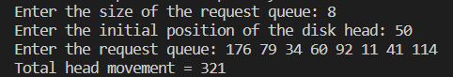

**C-SCAN DISK SCHEDULING ALGORITHM**

#include <stdio.h>

#include <stdlib.h>

#define MAX 200

void c_scan(int arr[], int head, int size)

{

int total_movement = 0;

int current = head;

int start_index = 0;

int i;

// Sort the request queue in ascending order

for (i = 0; i < size; i++) {

for (int j = i+1; j < size; j++) {

if (arr[i] > arr[j]) {

int temp = arr[i];

arr[i] = arr[j];

arr[j] = temp;

}

}

}

// Find the index at which the head starts moving towards the end of the disk

for (i = 0; i < size; i++) {

if (arr[i] > head) {

start_index = i;

break;

}

}

// Traverse the request queue in the direction of the head movement

for (i = start_index; i < size; i++) {

total_movement += abs(current - arr[i]);

current = arr[i];

}

// If the last request is not at the end of the disk, move to the end of the disk

if (arr[size-1] != 199) {

total_movement += abs(current - 199);

current = 199;

}

// Move to the beginning of the disk

total_movement += 199;

current = 0;

// Traverse the request queue in the direction of the head movement again

for (i = 0; i < start_index; i++) {

total_movement += abs(current - arr[i]);

current = arr[i];

}

printf("Total head movement = %d\n", total_movement);

}

int main()

{

int n, head, arr[MAX];

printf("Enter the size of the request queue: ");

scanf("%d", &n);

printf("Enter the initial position of the disk head: ");

scanf("%d", &head);

printf("Enter the request queue: ");

for (int i = 0; i < n; i++) {

scanf("%d", &arr[i]);

}

c_scan(arr, head, n);

return 0;

}

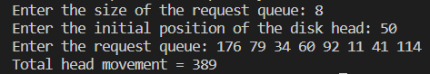

**FCFS DISK SCHEDULING ALGORITHM**

#include <stdio.h>

#include <stdlib.h>

#define MAX 200

void fcfs(int arr[], int head, int size)

{

int total_movement = 0;

int current = head;

for (int i = 0; i < size; i++) {

total_movement += abs(current - arr[i]);

current = arr[i];

}

printf("Total head movement = %d\n", total_movement);

}

int main()

{

int n, head, arr[MAX];

printf("Enter the size of the request queue: ");

scanf("%d", &n);

printf("Enter the initial position of the disk head: ");

scanf("%d", &head);

printf("Enter the request queue: ");

for (int i = 0; i < n; i++) {

scanf("%d", &arr[i]);

}

fcfs(arr, head, n);

return 0;

}

**LOOK DISK SCHEDULING ALGORITHM**

#include <stdio.h>

#include <stdlib.h>

#define MAX 200

void look(int arr[], int head, int size)

{

int total_movement = 0;

int current = head;

int start_index = 0;

int end_index = size-1;

// Sort the request queue in ascending order

for (int i = 0; i < size; i++) {

for (int j = i+1; j < size; j++) {

if (arr[i] > arr[j]) {

int temp = arr[i];

arr[i] = arr[j];

arr[j] = temp;

}

}

}

// Find the index at which the head starts moving towards the end of the disk

for (int i = 0; i < size; i++) {

if (arr[i] > head) {

start_index = i;

break;

}

}

// If the head moves towards the end of the disk

if (start_index != 0) {

end_index = start_index-1;

}

// Traverse the request queue in the direction of the head movement

for (int i = start_index; i < size; i++) {

total_movement += abs(current - arr[i]);

current = arr[i];

}

for (int i = end_index; i >= 0; i--) {

total_movement += abs(current - arr[i]);

current = arr[i];

}

printf("Total head movement = %d\n", total_movement);

}

int main()

{

int n, head, arr[MAX];

printf("Enter the size of the request queue: ");

scanf("%d", &n);

printf("Enter the initial position of the disk head: ");

scanf("%d", &head);

printf("Enter the request queue: ");

for (int i = 0; i < n; i++) {

scanf("%d", &arr[i]);

}

look(arr, head, n);

return 0;

}

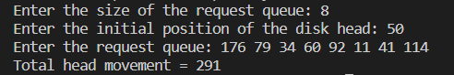

**SCAN DISK SCHEDULING ALGORITHM**

#include <stdio.h>

#include <stdlib.h>

#define MAX 200

void scan(int arr[], int head, int size)

{

int total_movement = 0;

int current = head;

int start_index = 0;

int i;

// Sort the request queue in ascending order

for (i = 0; i < size; i++) {

for (int j = i+1; j < size; j++) {

if (arr[i] > arr[j]) {

int temp = arr[i];

arr[i] = arr[j];

arr[j] = temp;

}

}

}

// Find the index at which the head starts moving towards the end of the disk

for (i = 0; i < size; i++) {

if (arr[i] > head) {

start_index = i;

break;

}

}

// Traverse the request queue in the direction of the head movement

for (i = start_index; i < size; i++) {

total_movement += abs(current - arr[i]);

current = arr[i];

}

// Add the movement to the end of the disk

total_movement += abs(current - 199);

current = 199;

// Reverse direction and move towards the beginning of the disk

for (i = start_index-1; i >= 0; i--) {

total_movement += abs(current - arr[i]);

current = arr[i];

}

printf("Total head movement = %d\n", total_movement);

}

int main()

{

int n, head, arr[MAX];

printf("Enter the size of the request queue: ");

scanf("%d", &n);

printf("Enter the initial position of the disk head: ");

scanf("%d", &head);

printf("Enter the request queue: ");

for (int i = 0; i < n; i++) {

scanf("%d", &arr[i]);

}

scan(arr, head, n);

return 0;

}

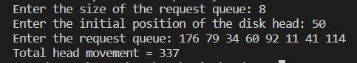

**SSTF DISK SCHEDULING ALGORITHM**

#include <stdio.h>

#include <stdlib.h>

#define MAX 200

void sstf(int arr[], int head, int size)

{

int total_movement = 0;

int visited[MAX] = {0};

int current = head;

for (int i = 0; i < size; i++) {

int shortest_distance = __INT_MAX__;

int selected = -1;

for (int j = 0; j < size; j++) {

if (!visited[j]) {

int distance = abs(current - arr[j]);

if (distance < shortest_distance) {

shortest_distance = distance;

selected = j;

}

}

}

visited[selected] = 1;

total_movement += shortest_distance;

current = arr[selected];

}

printf("Total head movement = %d\n", total_movement);

}

int main()

{

int n, head, arr[MAX];

printf("Enter the size of the request queue: ");

scanf("%d", &n);

printf("Enter the initial position of the disk head: ");

scanf("%d", &head);

printf("Enter the request queue: ");

for (int i = 0; i < n; i++) {

scanf("%d", &arr[i]);

}

sstf(arr, head, n);

return 0;

}

**OPEN ENDED QUESTION**

(a) Repository/Directory Synchronizer: Client-server application which is capable to synchronize the local changes to a remote folder.

(b) WAP for your own Signal Handler which will execute when you type (CTRL+D)

#include <stdio.h>

#include <stdlib.h>

#include <signal.h>

void handle_signal(int signal) {

printf("\nReceived signal %d. Exiting...\n", signal);

exit(EXIT_SUCCESS);

}

int main() {

// Install the signal handler for SIGINT

if (signal(SIGINT, handle_signal) == SIG_ERR) {

perror("signal");

return EXIT_FAILURE;

}

// Loop until CTRL+D is typed

printf("Type CTRL+D to exit...\n");

while (1) {

if (getchar() == EOF) {

handle_signal(SIGINT);

}

}

return EXIT_SUCCESS;

}

**INDEX**

|  |  |  |  |  |
| --- | --- | --- | --- | --- |
| S.No | Title | Date Allotted | Date Checked | Sign/ Remarks |
| 1. | Linux Terminal Commands | 3/01/2023 |  |  |
| 2. | Linux Shell Commands | 10/01/2023 |  |  |
| 3. | Linux Shell Programs | 17/01/2023 |  |  |
| 4. | Shell Script | 24/01/2023 |  |  |
| 5. | Process Scheduling(FCFS) | 7/02/2023 |  |  |
| 6. | Process Scheduling(SJF) | 14/02/2023 |  |  |
| 7. | Process Scheduling(SRTF) | 14/02/2023 |  |  |
| 8. | Process Scheduling(Non-preempti ve Priority) | 21/02/2023 |  |  |
| 9. | Process Scheduling(Preemptive Priority) | 21/02/2023 |  |  |
| 10. | Process Scheduling(Round Robin) | 28/02/2023 |  |  |
| 11. | Resource Allocation and Safe States(Banker’s Algorithm) | 13/03/2023 |  |  |
| 12. | Page Re-Allocation (FIFO) | 04/04/2023 |  |  |
| 13. | Page Re-Allocation (LRU) | 04/04/2023 |  |  |
| 14. | Page Re-Allocation (Optimal) | 04/04/2023 |  |  |

**AMITY SCHOOL OF ENGINEERING & TECHNOLOGY**

AMITY UNIVERSITY CAMPUS, SECTOR-125, NOIDA-201303

**OPERATING SYSTEM LAB**

PRACTICAL FILE

COURSE CODE: CSE202

Submitted to: Submitted by:

Dr Sumit Kumar Nandini Sain

4CSE6(X)